* Amino acids are building blocks of proteins
* Each amino acid has a common part
  + Alpha amino group that has alpha carbon
  + Alpha carboxylic acid – acidic end
  + Amino group is the organic basic group
  + Form nh3+ in water – carboxylic group will become charged – COO-
  + Side chain is different from one amino acid to another
  + Chirality
  + Optically active asymmetric chiral molecule
  + At neutral pH, as it has both positive and negative charge the net charge is 0 -> zwitterion
* Carbon is usually shown as black or green
* Oxygen is usually red – cuz it represents blood, life – haemoglobin
* Nitrogen is blue – also called azote – thunder has lots of charges and thunder is blue – nitrogen becomes ammonia
* All amino acid except glycine has asymmetric alpha-carbon
* Glycine has 2 H so not asymmetric
* D-amino acid can make immune responses
* There are more than 20 amino acids but only focus on 20 amino acids cuz humans
* Lots of amino acids are nonpolar (10 amino acids) - hydrophobic
* Methionine is the start codon of most genes
* 3 amino acid codes
* Rings make it hard to twist around – more stable
* 10 amino acids are polar - hydrophilic
* Polars do not lose protons – they form hydrogen bonds
* ¼ of the amino acids are charged – asparctic acid and glutamic acid are highly negative
* Glutamic acid in Chinese sauces – soy sauce, oyster sauce
* Histidine is basic but operate around very neutral pH
* Hydrophilic stays at the surface of the protein while hydrophobics are wrapped inside
* Blue is basic; red for acid; Histidine is mild basic

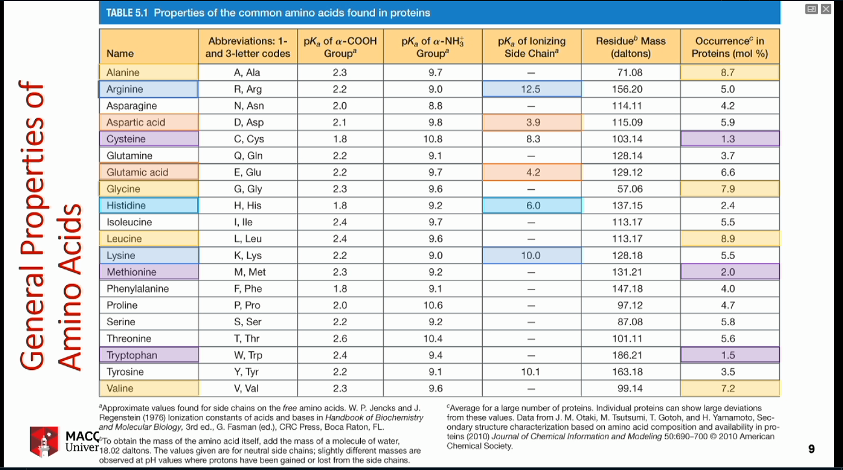

* Amino acids range in codon frequency – glycine, leucine, and valine are over-represent – hydrophobic – nonpolar – we like them a lot
* ATG has sulphur in side chain
* Tryptophan only has one codon – UGG
* Charged amino acid – equilibrium
* 0 to 14 is the Ph range
* Ammonium ion is NH4+ - can give away proton
* Imidazole is a mild base – has almost neutral Ph – the group found in Histidine
* 20 standard amino acids have common backbone but different side chains – only 5 are ionised (charged) that can interact
* Bases are proton acceptors
* Bronsted-Lowry definition
* Strong base associates completely into conjugate acid – organised – accept protons – rarely found in neutral form
* Strong acids will fully ionise
* Water is the principle source of proton to make acids charged – to accept protons from bases
* Water can self protonate
* Equilibrium means it goes back and forth – not fully in one direction – depending on temperaure
* Make life easier by writing H3O+ as H+
* 1 water molecule gives equal amount of H+ and OH-
* Concentration is in [ ]
* Equilibrium constant defines ratio of the equation:

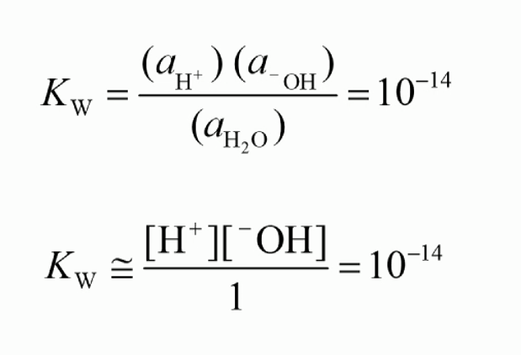

* Concentrationof water equals 1
* Kw = 10^-14 -> Proton = 10^7
* Water makes acid behaves like acid and base behaves like base
* Ion product is Kw (10-14)
* pH was proposed – potential/power/wtv of hydrogen – use log scale

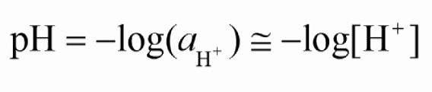

* log1 = 0
* 1 M HCl = 0; very acidic; occur in tummy but slightly less than 1 M
* 1 M NaOH = 14; very basic
* Most biochemistry occurs in pH in 6 to 8
* Bio reactions take place between pH 6.5 and 8
* Human operates in pH 7.4
* Water hardly is at pH 7; either basic or acidic
* Surface of proteins have polar charges – 50% are charged (like water)
  + Highly positively charged in low pH (acidic)
  + The same enzyme can react differently in different environment
  + When you get sick, your blood pH changes – enzyme changes – feel weak bcuz body is using a lot of energy
* Isoelectric point (pl) = 6.8
* 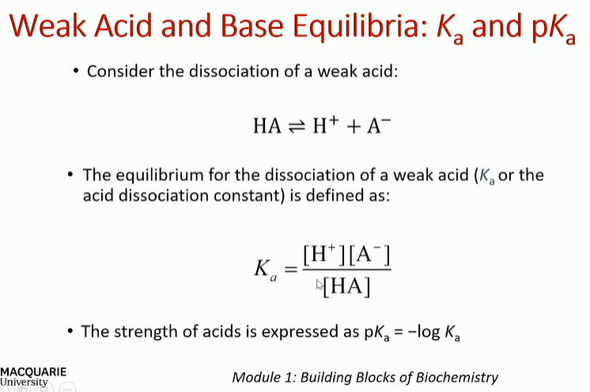
* Ka is low bcuz we are dealing with weak acids and bases
* PKa measures the acidity of acid
* In chemistry, equilibrium is measured at 0 K
* In biochemistry, pKa is measured at 25 degrees
* Bicarbonate ion controls our blood pH
* Ammonium is toxic – ammonia goes into urea (non-toxic)
* Henderson-Hasselbalch
  + If ph = pka ; [HA] = [A-]
* Buffer range is the range of pH that the molecules do not change rapidly from base to acid and vice versa

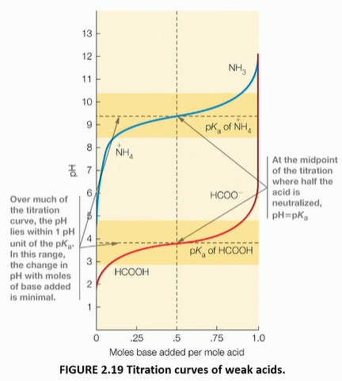

* Buffer will resist pH change within 1 unit of pH or 100 times of Ka